**SCIENCE DEPARTMENT**

**YEAR 11**

**HUMAN BIOLOGY EXAMINATION**

**SEMESTER 1, 2008**

|  |  |  |  |  |
| --- | --- | --- | --- | --- |
| **Student Name:** |  |  | **Form:** |  |

**Time allowed for this paper**

Reading time before commencing work: 10 minutes

Working time for paper: 3 hours

**Materials required / recommended for this paper**

To be provided by the supervisor

Question / Answer Booklet – Section B

Separate Multiple Choice Booklet

Standard Answer Book – MCQ and Essays

To be provided by the candidate

*Standard items:* Pens, pencils, eraser or correction fluid, ruler

*Special items:* A 2B, B or HB pencil for the separate Multiple Choice Answer Sheet and calculators satisfying the conditions set by the Curriculum Council for this subject.

**Important note to candidates**

No other items may be taken into the examination room. It is **your** responsibility to ensure that you do not have any unauthorised notes or other items of a non-personal nature in the examination room. If you have any unauthorised material with you, hand it to the supervisor **before** reading any further.

**Structure of this paper**

|  |  |  |  |
| --- | --- | --- | --- |
| **Section** | **Number of questions available** | **Number of questions to be attempted** | **Marks available** |
| A Multiple Choice | 40 | 40 | /40 |
| B Short Answer questions | 10 | 10 | /40 |
| C Extended Answer questions: | 2 | 2 | /20 |
|  |  | **Total Marks** | **/100** |

**Instructions to candidates**

1. Answer the questions according to the following instructions.

**Section A** Answer ALL multiple choice questions by crossing out the letter of your choice on the Answer Sheet provided. Use 2B pencil here.

**Section B** Answer the questions in the spaces provided. Answers to be in BLUE or BLACK biro. GRAPHS and DRAWINGS to be in pencil.

**Section C** ALL PARTS OF QUESTIONS 1 or 2 and ALL PARTS OF QUESTIONS 3 or4

Write the answer on the lined paper provided.

2. You should note that the space made available for an answer is not necessarily an indication of the length of the answer.

3. You must not take this Question/Answer Booklet away from the examination room.

**SECTION I MULTIPLE CHOICE (40 %)**

Answer ALL questions in this section.

1. The series of interconnecting canals that transport fluid through a cell are called:
   1. Endoplasmic Reticulum.
   2. Centrioles.
   3. Golgi bodies.
   4. Mitochondria.
2. The type of tissue lining the digestive tract is:
   1. Epithelial tissue.
   2. Connective tissue.
   3. Muscular tissue.
   4. Contractile tissue.
3. Any group of cells of similar structure that perform a specific task are referred to as:
   1. A system.
   2. A tissue.
   3. An organ.
   4. A nerve.
4. Which of the following is the site for aerobic respiration?
   1. Nucleus.
   2. Cytoplasm.
   3. Mitochondria.
   4. Ribosomes.
5. The appendicular skeleton consists of the:
6. skull
7. shoulder blade and pelvis
8. limb girdles and limbs
9. collar bone and arms
10. During the process of mitosis there are a number of clearly visible stages. During which stage does replication of DNA occur?
    1. Interphase.
    2. Prophase.
    3. Metaphase.
    4. Anaphase.
11. Which of the following organelles would you expect to be more numerous in a muscle cell than in a bone cell?
    1. Ribosomes.
    2. Mitochondria.
    3. Centrioles.
    4. Lysosomes.
12. Students observed a cell under high power of a microscope using a 10X ocular lens and a 40X objective lens. The cells appeared to have the width of 24mm. If the objective lens was changed to 10X, what would be the width of the cells?
    1. 96mm.
    2. 24mm.
    3. 6mm.
    4. 12mm.
13. ATP is essential to every living cell because it:
    1. Stores energy released during the breakdown of ADP.
    2. Speeds up the digestion of food.
    3. Stores energy in a form that is readily available.
    4. Reacts with energy from glucose to form ADP.
14. Cells use as their main source of energy which of the following?
    1. Sugar.
    2. Glucose.
    3. Amino acids.
    4. Fats.
15. A student made a wet mount of a letter that she observed under the microscope on low power as ‘d’. What letter did she make the slide of?
    1. ‘b’
    2. ‘p’
    3. ‘d’
    4. ‘q’
16. In evolution of primates the relative importance of the sense of smell has:
    1. Decreased.
    2. Remained of little importance.
    3. Remained constant.
    4. Increased.
17. Which of the following would not be included in the primate group ‘anthropoid’?
    1. Baboon.
    2. Gibbon.
    3. Lemur.
    4. Gorilla.
18. Which of the following terms refers to having five digits on the hand?
    1. Digitalis.
    2. Pentadactyl.
    3. Opposability.
    4. Dimorphism.
19. A newly discovered primate has the following characteristics: large teeth, quadrupedal, terrestrial, a non-prehensile tail. Into which category would it best fit?
    1. Prosimian.
    2. New world monkey.
    3. Old world monkey.
    4. Apes.
20. What is the scientific name for “Old world” monkey?
    1. Hominoidea.
    2. Ceboidea.
    3. Cercopithecoidea.
    4. Prosimii.
21. One characteristic that humans do not share with the other anthropoids is:
    1. The ability to use tools.
    2. Opposability of the thumbs.
    3. Having longer legs than arms.
    4. Stereoscopic vision.
22. Which of the following describe features of the human foot that allows us to walk bipedally?
    1. Large toes and heel bone.
    2. A transverse arch and an opposable big toe.
    3. A non opposable big toe and a transverse arch.
    4. A large heel bone and prehensile toes.
23. Which of the following lists states the major levels of taxonomic classification in order of decreasing diversity within each level?
    1. Species, genus, order, class, family.
    2. Class, order, family, genus, species.
    3. Order, class, species, family, genus.
    4. Class, order, genus, family, species.
24. Which of the following statements is incorrect?

The skeleton:–

1. acts as a framework for the attachment of muscles and as a system of levers
2. encloses delicate organs and gives them protection
3. contains considerable quantities of non-cellular solid matrix
4. is strengthened by the addition of chitin, especially at the pelvis
5. Examine the primate below. This primate belongs to the sub-order?

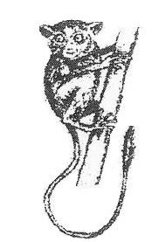

* 1. Anthropoidea.
  2. Tarsiidae.
  3. Mammalia.
  4. Prosimii.

1. The primate pictured below belongs to the group of Primates known as:

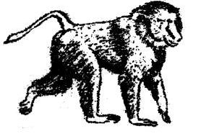

* 1. Hominoidea.
  2. Tupaioidea.
  3. Ceboidea.
  4. Cercopithecoidea.

1. Examine the diagram of a muscle fibre below:

A Band

I Band

The A band shown above is made up of

* 1. actin and myosin fibres
  2. actin and creatine fibres
  3. myosin fibres only
  4. actin fibres only

1. Consider the muscles X and Y in the fingers as shown below.

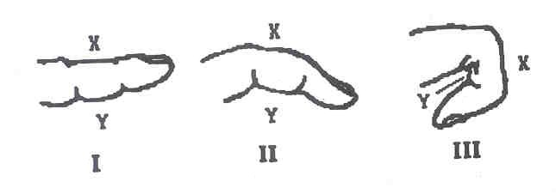

When the finger is in position I:

* 1. muscle X is relatively relaxed; muscle Y is contracted.
  2. muscle X is contracted; muscle Y is relaxed.
  3. both muscles are relaxed.
  4. both muscles are contracted.

1. Some species of primates are territorial. Which one of the following species uses scent to mark its territory?
   1. Orangutans
   2. Lemurs
   3. Chimpanzees
   4. Baboons
2. Of the hands shown below, which is most probably a member of the Prosimians?

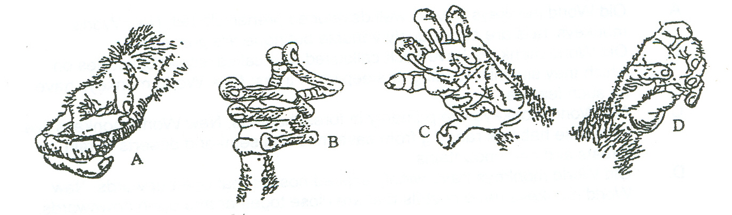

* 1. Hand A
  2. Hand B
  3. Hand C
  4. Hand D

1. Which of the letters below on the diagram represent a hinge joint?

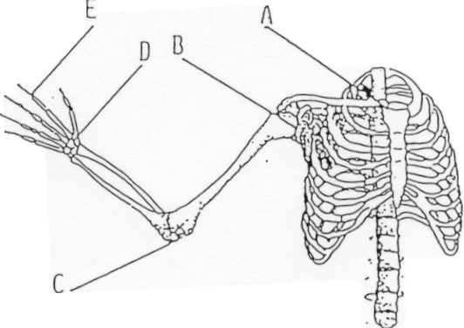

* 1. A
  2. B
  3. C
  4. D

1. The diagram below illustrates some of the many events in mitosis.

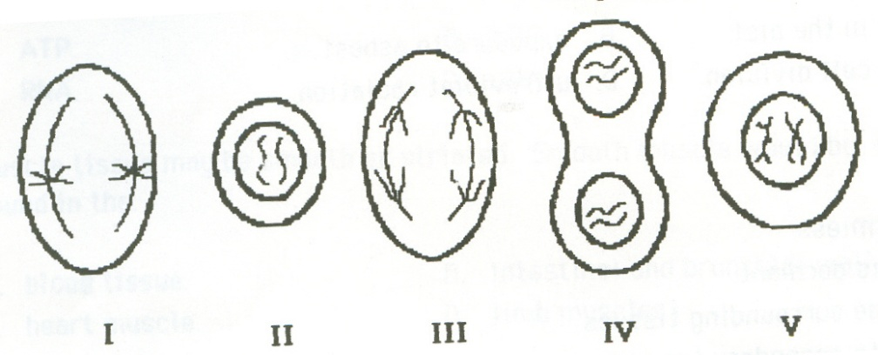

The correct sequence of these events is as follows:

* 1. IV, II, III, V, I
  2. IV, III, V, I, II
  3. I, V, III, II, IV
  4. V, I, III, IV, II

1. Smooth muscle tissue:
   1. forms the walls of the heart
   2. is in the walls of veins
   3. is attached to the skeleton
   4. is consciously controlled.
2. A benign tumour:
   1. is always harmless
   2. is one which is dormant
   3. does not invade surrounding tissues
   4. can give rise to secondary tumours.
3. Which of the following vertebrae are connected through moveable joints with the ribs?
   1. Sacral.
   2. Lumbar.
   3. Cervical.
   4. Thoracic.
4. An enzyme is a/an:
   1. Chemical messenger.
   2. Carbohydrate.
   3. Organic catalyst.
   4. Inorganic substance.
5. A membrane which allows the passage of certain molecules only is said to be:
   1. Fully permeable.
   2. Permeable.
   3. Impermeable.
   4. Differentially permeable.
6. Which of the following terms describes a displacement of a joint with the tearing of ligaments, tendons or capsules?
   1. Sprain
   2. Fracture
   3. Strain
   4. Dislocation
7. Give the name of the following joint.

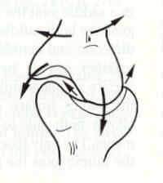

* 1. Hinge joint.
  2. Ball and Socket joint.
  3. Gliding Joint.
  4. Saddle Joint.

1. Choose the correct term that describes the movements shown in the diagram below.

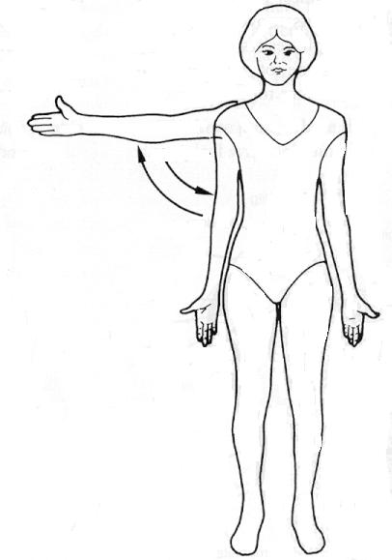

* 1. Flexion and extension.
  2. Abduction and adduction.
  3. Pronation and supination.
  4. Rotation

1. The bones that form the axial skeleton are:
   1. Humerus, Ribs and vertebral column.
   2. Cranium, vertebral column, ribs and sternum.
   3. Pelvis, Vertebral column and Cranium.
   4. Cranium, ribs and shoulder girdle.
2. A joint which allows very free movement is called:
3. a synovial joint
4. a suture
5. an immovable joint
6. a symphysis
7. Protective padding around the kidney and behind the eye is composed of:
   1. Cartilage
   2. white fibrous tissue
   3. adipose tissue
   4. yellow elastic tissue
8. Co-ordination of muscles is necessary for movement of the human body. The term which best describes how opposite pairs of muscles work is:
   1. Skeletal muscles
   2. Agonistic
   3. Antagonistic
   4. Apathetic

**END OF SECTION A**

**HUMAN BIOLOGY SEMESTER 1 EXAM**

**MULTIPLE CHOICE ANSWER SHEET**

**STUDENT NAME: CLASS:**

***Please indicate your answer with a cross (X) within the box.***

|  |  |  |  |  |  |  |  |  |  |  |
| --- | --- | --- | --- | --- | --- | --- | --- | --- | --- | --- |
| **1** | A | B | C | D |  | **21** | A | B | C | D |
| **2** | A | B | C | D |  | **22** | A | B | C | D |
| **3** | A | B | C | D |  | **23** | A | B | C | D |
| **4** | A | B | C | D |  | **24** | A | B | C | D |
| **5** | A | B | C | D |  | **25** | A | B | C | D |
| **6** | A | B | C | D |  | **26** | A | B | C | D |
| **7** | A | B | C | D |  | **27** | A | B | C | D |
| **8** | A | B | C | D |  | **28** | A | B | C | D |
| **9** | A | B | C | D |  | **29** | A | B | C | D |
| **10** | A | B | C | D |  | **30** | A | B | C | D |
| **11** | A | B | C | D |  | **31** | A | B | C | D |
| **12** | A | B | C | D |  | **32** | A | B | C | D |
| **13** | A | B | C | D |  | **33** | A | B | C | D |
| **14** | A | B | C | D |  | **34** | A | B | C | D |
| **15** | A | B | C | D |  | **35** | A | B | C | D |
| **16** | A | B | C | D |  | **36** | A | B | C | D |
| **17** | A | B | C | D |  | **37** | A | B | C | D |
| **18** | A | B | C | D |  | **38** | A | B | C | D |
| **19** | A | B | C | D |  | **39** | A | B | C | D |
| **20** | A | B | C | D |  | **40** | A | B | C | D |

**SECTION C EXTENDED ANSWERS (20 %)**

Answer questions on the paper provided. Illustrate your answers with diagrams where appropriate. Up to TWO MARKS may be deducted for poorly structured answers, ie answers in point form or diagrams not explained in the text of your answer.

DO NOT WRITE YOUR ANSWERS IN PENCIL.

**ANSWER QUESTION 1 OR 2** AND **QUESTION 3 OR 4**

1. (a) Describe an enzyme. [2 marks]

(b) Enzymes have specificity. How is this achieved? [2 marks]

(c) Describe the factors which influence the activity of enzymes. [4 marks]

(d) Distinguish between the three major types of joints on the basis of both structure and function, making sure the various synovial joints are described. Include labelled diagrams where appropriate and provide examples of specific locations and the possible range of movements these joints allow. [12 marks]

**OR**

2. (a) Describe the structure of a typical long bone, both from its external appearance and its internal appearance seen in longitudinal section. Include a diagram.

[10 marks]

(b) Describe the sliding filament model for muscle contraction. [10 marks]

**AND**

**AND**

3.

Cell division is important for growth and to replace old, damaged or diseased cells.

Explain the process which passes on the same hereditary material to offspring.

Include clear labelled diagrams to illustrate your answer.

[20 marks]

**OR**

4.

Once a muscle is stimulated, it requires energy to contract. The energy comes from a chemical reaction. Describe the processes which produce energy for the muscles of a

runner in a sprint race and also during an endurance race.

[20 marks]

____________________________________________________________________________________________________________________________________________________________________________________________________________________________________________________________________________________________________________________________________________________________________________

____________________________________________________________________________________________________________________________________________________________________________________________________________________________________________________________________________________________________________________________________________________________________________

____________________________________________________________________________________________________________________________________________________________________________________________________________________________________________________________________________________________________________________________________________________________________________

____________________________________________________________________________________________________________________________________________________________________________________________________________________________________________________________________________________________________________________________________________________________________________

____________________________________________________________________________________________________________________________________________________________________________________________________________________________________________________________________________________________________________________________________________________________________________

____________________________________________________________________________________________________________________________________________________________________________________________________________________________________________________________________________________________________________________________________________________________________________

____________________________________________________________________________________________________________________________________________________________________________________________________________________________________________________________________________________________________________________________________________________________________________

____________________________________________________________________________________________________________________________________________________________________________________________________________________________________________________________________________________________________________________________________________________________________________

____________________________________________________________________________________________________________________________________________________________________________________________________________________________________________________________________________________________________________________________________________________________________________

____________________________________________________________________________________________________________________________________________________________________________________________________________________________________________________________________________________________________________________________________________________________________________

____________________________________________________________________________________________________________________________________________________________________________________________________________________________________________________________________________________________________________________________________________________________________________

____________________________________________________________________________________________________________________________________________________________________________________________________________________________________________________________________________________________________________________________________________________________________________

____________________________________________________________________________________________________________________________________________________________________________________________________________________________________________________________________________________________________________________________________________________________________________

____________________________________________________________________________________________________________________________________________________________________________________________________________________________________________________________________________________________________________________________________________________________________________

____________________________________________________________________________________________________________________________________________________________________________________________________________________________________________________________________________________________________________________________________________________________________________

____________________________________________________________________________________________________________________________________________________________________________________________________________________________________________________________________________________________________________________________________________________________________________

____________________________________________________________________________________________________________________________________________________________________________________________________________________________________________________________________________________________________________________________________________________________________________

____________________________________________________________________________________________________________________________________________________________________________________________________________________________________________________________________________________________________________________________________________________________________________

____________________________________________________________________________________________________________________________________________________________________________________________________________________________________________________________________________________________________________________________________________________________________________

____________________________________________________________________________________________________________________________________________________________________________________________________________________________________________________________________________________________________________________________________________________________________________

____________________________________________________________________________________________________________________________________________________________________________________________________________________________________________________________________________________________________________________________________________________________________________

____________________________________________________________________________________________________________________________________________________________________________________________________________________________________________________________________________________________________________________________________________________________________________

____________________________________________________________________________________________________________________________________________________________________________________________________________________________________________________________________________________________________________________________________________________________________________

____________________________________________________________________________________________________________________________________________________________________________________________________________________________________________________________________________________________________________________________________________________________________________

____________________________________________________________________________________________________________________________________________________________________________________________________________________________________________________________________________________________________________________________________________________________________________

____________________________________________________________________________________________________________________________________________________________________________________________________________________________________________________________________________________________________________________________________________________________________________

____________________________________________________________________________________________________________________________________________________________________________________________________________________________________________________________________________________________________________________________________________________________________________

____________________________________________________________________________________________________________________________________________________________________________________________________________________________________________________________________________________________________________________________________________________________________________

____________________________________________________________________________________________________________________________________________________________________________________________________________________________________________________________________________________________________________________________________________________________________________

____________________________________________________________________________________________________________________________________________________________________________________________________________________________________________________________________________________________________________________________________________________________________________

____________________________________________________________________________________________________________________________________________________________________________________________________________________________________________________________________________________________________________________________________________________________________________

____________________________________________________________________________________________________________________________________________________________________________________________________________________________________________________________________________________________________________________________________________________________________________

____________________________________________________________________________________________________________________________________________________________________________________________________________________________________________________________________________________________________________________________________________________________________________

____________________________________________________________________________________________________________________________________________________________________________________________________________________________________________________________________________________________________________________________________________________________________________

____________________________________________________________________________________________________________________________________________________________________________________________________________________________________________________________________________________________________________________________________________________________________________

____________________________________________________________________________________________________________________________________________________________________________________________________________________________________________________________________________________________________________________________________________________________________________